PREDICTIVE FACTORS OF ACCULTURATIVE STRESS AMONG LATINO/A/X AND/OR HISPANIC COLLEGE STUDENTS

by

Crystal Adote

A thesis submitted to the Graduate Faculty in Psychology in partial fulfillment of the requirements for the degree of Master of Science in Psychological Research, Brooklyn College – City University of New York

2026

© 2026
Crystal Adote
All Rights Reserved

Predictive factors of acculturative stress among Latino/a/x and/or Hispanic college students
by
Crystal Adote

This manuscript has been read and accepted for the Graduate Faculty in Psychology in satisfaction of the Thesis requirement for the degree of Master of Science in Psychological Research.

May 25, 2026
Date |  | XXXXX, Ph.D.
Chair of Examining Committee

Supervisory Committee:
Yana Kuchirko, Ph.D.
Laura Reigada, Ph.D.
Jacob Shane, Ph.D.

BROOKLYN COLLEGE – CITY UNIVERSITY OF NEW YORK

ABSTRACT

Predictive factors of acculturative stress among Latino/a/x and/or Hispanic college students
by
Crystal Adote

Thesis Advisor: Yana Kuchirko, Ph.D

Many immigrants and international students experience hardships as they try to adapt to a new cultural environment, a phenomenon known as acculturative stress. While research has examined acculturative stress among immigrants and their children, specific factors that may contribute to this type of stress remain unexamined. This study examined predictive contextual and cultural factors of acculturative stress among Latinos/as/x and Hispanic college students specifically. Students completed a survey that collected data on their demographics, critical consciousness, and the S.A.F.E. Acculturation Stress Scale. Two independent t-tests were conducted with immigrant generation and employment status and acculturative stress. Two Spearman correlations were also conducted to examine the association between acculturative stress and religiosity and critical consciousness. Results show that none of the selected predictors were statistically significant and did not relate to acculturative stress levels. However, the findings from this study can provide insight into how to support Latine communities and inform the research community about factors that contribute to acculturative stress.
Keywords: Acculturative stress, Latinos/as/x, Hispanic, predictors

Acknowledgements
A big thank you to the Brooklyn College Psychology Department, and to my thesis committee, Yana Kuchirko, Laura Reigada, and Jacob Shane.

Table of contents
General Introduction ……………………………………………………………….…………….8
Acculturation Process..…….…………………………………………………….……...……10
Acculturation among Latine Communities…….……………………………….………....…11
Acculturation among Young Adulthood…………………………………….……………..…15
Current Study……………………………………………………………………………………16
Experiment 1…………………………………………………………………………………….16
Methods………………………………………………………………………………………16
Participants…………………………………………………………………………...……17
Procedure………………………………………………………………………………….17
Measures…………………………………………………………………………………..17
Data Analysis…………………………………………………...……………………………19
Results……..…………………………………………………………………………………20
Discussion....…………………………………………………………………………………22
Limitations and Future Directions…………………………………………………………24
General Discussion …………………..………………………………………………………….26
References ………..…………………..…………………………………………………………27

List of figures
Figure 1. Acculturative Stress Scores (page 32)
Figure 2. Employment status and Acculturative Stress t-test (page 32)
Figure 3. Immigrant Generation Status and Acculturative Stress t-test (page 33)
Figure 4. Religiosity and Acculturative Stress correlation (page 33)
Figure 5. Critical Reflection and Acculturative stress correlation (page 34)
Figure 6. Critical Efficacy and Acculturative Stress correlations (page 34)
Figure 7. Critical Action and Acculturative Stress correlation (page 35)
Figure 8. Combined correlations (page 35)

General Introduction
As of 2023, the Hispanic community accounted for 19.5% of the total U.S. population, which is 65.2 million individuals, making them the largest ethnic group in the nation (Census Bureau, 2024). Despite being a large community, individuals who are part of this community experience negative stressors such as discrimination and racism to name a few. Recent data from large nationally representative studies suggest greater increases in anxiety and depression symptoms among REM (racially and ethnically minoritized groups) adolescents and young adults than their white counterparts. These disparities have been attributed, in part, to structural and contextual stressors associated with minoritized status, including increased experiences of discrimination, prejudice, immigration policy changes, and acculturation-related stressors (Louie &Wheaton, 2018; National Healthcare Quality and Disparities Report, 2022; Lipson et al., 2022; Tineo et al., 2024).
In this study, I focus on stress related to acculturation among U.S. Latine young adults. Acculturative stress is defined as the emotional and psychological strain experienced during the acculturation process, particularly when individuals attempt to navigate the demands of a dominant culture while maintaining connections to their culture of origin. This construct has been widely documented among immigrants, refugees, and international students, and has been associated with adverse mental health outcomes, including depression, anxiety, and psychological distress. Acculturation is known as the process of adapting to a new/dominant culture and adopting their values, customs, and behaviors. Although acculturation can facilitate social integration, it can also introduce unique stressors, such as cultural loss, identity conflict, and experiences of exclusion. The processes of adaptation, erosion, and cultural change may operate as sources of stress that elicit varied psychological and emotional responses among immigrant and immigrant-origin populations (Castañeda et al., 2015; Kahar & Negroni, 2020).
When discussing psychological acculturation, Berry (1997) notes that acculturative stress can be understood as culture shock. However, Berry (1997) prefers the acculturative stress conceptualization rather than “culture shock” because a) it is connected to psychological models of stress as a response to environmental stressors, so it has some theoretical foundation, b) “shock” suggests that there are only negative experiences and outcomes when it comes to intercultural contact, but during acculturation, only moderate challenges are experienced (i.e., psychosomatic problems), while other psychological processes (e.g., coping strategies) are available to individuals experiencing acculturation. c) the source of the problems that come up is intercultural and not just cultural (Berry, 1997). This framework situates acculturative stress as a dynamic and context-dependent process rather than a uniform or inevitable outcome of cultural contact.
Previous research has examined acculturative stress among Latino immigrants and their children, as well as the possible mental health symptoms that arise from it, such as depression, anxiety, and suicide ideation. However, less attention has been paid to the contextual and sociocultural factors that may predict acculturative stress among young adults, particularly those enrolled in higher education. Moreover, previous studies have mostly focused on first-generation immigrants as participants rather than second-generation immigrants (e.g., immigrants’ children). In this study, I examine predictive factors of acculturative stress by surveying young Latine adults in the U.S. By identifying factors associated with acculturative stress in this population, my study aims to inform future research and intervention efforts targeting the well-being of Latine college students.
Acculturation Process
Acculturation is the process of adapting to a new culture. Past research has found links/relationships between acculturative stress and mental health symptoms such as anxiety and depression among individuals who suffer from it. Berry (1980) developed an acculturation model in which receiving-culture acquisition and heritage-culture retention are treated as independent dimensions that intersect to create 4 categories (Schwartz et al., 2010). The first category is assimilation, in which an individual adopts the receiving culture and disregards their heritage culture. The second category is separation, when an individual rejects the receiving culture and retains the heritage culture. The third category is integration, in which an individual adopts the receiving culture while retaining the heritage culture. The last category is marginalization, in which an individual rejects both the receiving and the heritage culture (Schwartz, 2010). This theoretical model is widely used in research on acculturation and acculturative stress. Importantly, these acculturation strategies are associated with differential psychological outcomes, with integration often linked to more adaptive outcomes and marginalization associated with elevated distress (Schwartz et al., 2010). Although this model has been widely used, research increasingly suggests that acculturative stress is shaped not only by acculturation orientation but also by broader social and institutional contexts in which acculturation occurs.
When discussing group-level acculturation, Berry (1997) explained that during the process, migrant groups experience several changes in their lives. One is a physical change, such as urbanization. Another is biological change, where individuals might be exposed to new diseases, which could affect their health, and their dietary intake may be different as well. The last one is economic changes, which can involve new employment opportunities or a loss of employment status. Such transformations illustrate how acculturation extends beyond cultural adaptation to encompass structural and material conditions, all of which may contribute to acculturative stress.
Acculturation among Latine Communities
In this study, I focus specifically on acculturation processes within Latine communities. I chose the Latine population for my study because of the growing visibility of their experiences in national discourse, particularly regarding discrimination, immigration, and sociopolitical marginalization. Although many Latine immigrants come to the United States in the hope of better opportunities, they often face challenges upon arrival. Some of these challenges include language barriers, exposure to prejudice, discrimination, and racism, and a shift in cultural expectations, which can make the acculturation process more difficult and lead to increased levels of acculturative stress (Arbona et al., 2010; Cavazos-Rehg et al., 2007). It is important to better understand the specific factors and lived experiences that shape acculturative stress among Latine individuals.
Acculturation processes among Latine communities are shaped by intersecting cultural, social, and structural factors. Research in this area has documented both protective and harmful consequences of acculturation, suggesting that its effects are neither uniform nor linear (Escarce et al., 2006; Kahar & Negroni, 2020). Understanding acculturative stress among Latine individuals, therefore, requires attention to cultural coping strategies, socioeconomic conditions, and institutional contexts.
The cultural stress theory is a framework that has emerged over the past few decades and conceptualizes the various stressors experienced by migrants and their children. Cultural stress can be defined as a multidimensional construct that includes stressors such as negative context of reception (i.e., feeling unwanted or unwelcome in a foreign country), perceived discrimination, and bicultural stressors (Ertanir et al., 2024). This theory is very similar to acculturative stress, as its foundations are also based on stressors individuals experience in a new, dominant culture, such as discrimination and bicultural pressures. Scaramutti-Gladfelter and colleagues (2025) examined the relationship between cultural stress and identity, and mental health outcomes in recently immigrated Venezuelan families. They found that higher levels of cultural stress were associated with increased mental health distress with both parents, but that cultural stress did not mediate the relationship between mental health and ethnic identity (Scaramutti-Gladfelter et al., 2025). These findings are similar to findings from past research on the relationship between acculturative stress and mental health, where it has been found that higher levels of acculturative stress were associated with negative mental health outcomes (Lerias et al., 2024).
Religion is a big part of Latino/a/x culture. “Latina women in the U.S. tend to use religious coping more frequently than their non-Hispanic peers. Use of religious coping is associated with less acculturation among foreign-born and U.S.-born Latinas in the U.S.” (Abraido-Lanza et al., 2004; Mausbach, et al.,2003; Silva et al., 2017). Positive religious coping provides community and support, helping people overcome current difficulties. Past findings suggest that positive religious coping may play a role in buffering the effects of acculturative stress on psychological distress experienced by recent Latina young adults who have migrated to the U.S. (Silva et al., 2017). Religion can be seen as a coping strategy for acculturative stress among the Latine community.
Another key factor in acculturative stress is employment. While prior studies have examined employment status in Latine communities, the outcomes have mainly focused on sleep and other facets of stress, rather than on acculturative stress specifically (Zhan et al., 2023). Although only employment status was included in this study, and the workplace environment was not, it is important to note briefly because this is a common experience among employed individuals and may help explain why employment status may predict acculturative stress. Research has shown that workplace environments could be a factor of acculturative stress. For instance, studies find factors related to the psychological distress of Latino Day Laborers (Negi, 2013). Their study incorporates the minority stress model, however, leaving out the first process (internalized homophobia) because of its lack of purpose with the topic of the study.
The minority stress model Meyer has proposed (1995) has been applied to sexual minority populations and has 3 processes of stress. The first one is internalized homophobia, the second one is perceived stigma, and the last one is prejudicial events. The theoretical model suggests that minorities experience great amounts of stress due to the discriminatory nature and stigmatization of the dominant culture. The model also suggests that these stressors are an addition to general stressors, which are experienced by a majority of populations and are rooted in institutions and sociocultural systems (Negi, 2013). Studies likewise found that social isolation and discrimination have significant impacts on Latino Day Laborers (LDLs) mental health. Acculturative stress levels could rise due to the stress they experience from discrimination and other factors in the work environment (Negi, 2013). In this study, I chose employment status as a demographic variable to examine both employed individuals and unemployed individuals to examine whether unemployment may also relate to acculturative stress.
Critical consciousness is an important factor to consider when examining acculturation and acculturative stress, since it can shape how individuals interpret and respond to inequality. Critical consciousness broadly refers to an individual’s awareness of social inequities and their motivation to engage in actions aimed at social change (Diemer et al., 2016). For instance, Rubio and colleagues (2021) examined the process by which a Mexican individual (Manuel) became a teacher in his hometown and later a bilingual teacher in a school in Central Texas. They note that a lack of critical consciousness led Manuel and his wife to make a decision that affected one of their daughters' education. While in the United States, Manuel had a desire to transform his school, district, and community. He states, “you begin to start fighting with the administration because you begin to have clearer ideas, and you take advantage of that in a faculty meeting or you take advantage of a meeting when you’re in a group, you begin to express these ideas” (Rubio et al., 2021, p. 56). Manuel gained his critical consciousness and is using his voice to advocate for his students and their families.
Manuel’s story conveys how high critical consciousness can support and benefit communities, especially during the acculturation process, by fostering a sense of belonging. Although critical consciousness has been theorized as empowering, some scholars suggest that heightened awareness of systemic inequality may also increase psychological distress when individuals lack sufficient resources or opportunities to enact change. Thus, the relationship between critical consciousness and acculturative stress may be context dependent. Cadenas, and colleagues (2024) findings highlight that discriminatory, exclusionary, and unwelcoming environmental factors that undocumented college students encounter in higher education and in society at large, chronically activate cultural stress in a way that it fosters high levels of distress (Cadenas, et al., 2024). Their findings also suggest that cultural stress motivates undocumented college students to increase their critical consciousness through advocacy and activism.
Finally, in addition to testing the relations between critical consciousness and acculturation, I examine whether immigrant generation and religiosity contribute to acculturative stress. I focus on these variables because prior research studies have looked at other variables, such as individuals’ age and gender, to name a few. Silva and colleagues (2017) examined religion among Latina women and found that they frequently use religious coping, which is associated with lower acculturation. Tse and colleagues (2026) examined the linear and quadratic effects of age of arrival to the United States (aged 12-54) and acculturative stress in predicting the probability of trajectory membership for each ethnic-racial identity (ERI) component among Mexican mothers. Although Negi (2013) examined Latino Day Laborers and the psychological distress they experience in the workplace, their sample was employed individuals.
Acculturation among Young Adulthood
I specifically focus on acculturation among Latine young adults, an underexamined demographic in prior research. Data from the most recent CDC Youth Risk Behavior Survey (2021) shows that Hispanic and multiracial students were more likely to have persistent sadness and hopelessness compared to other REM (racially and ethnically minoritized groups) and white youth (CDC, 2021; Tineo et al., 2024). Silva and colleagues (2024) found that societal factors such as economic instability, deportation fears, and discrimination were associated with increased levels of acculturative stress among Latino youth.
Research also suggests that immigrants typically have healthier diets than non-immigrants. Acculturation can also influence youth’s diet, as a study found that separated/marginalized youth may be vulnerable to unhealthy eating habits (Arandia et al., 2018). Studies also find that for Latino youth, discrimination was an important factor in students’ decisions to drop out of school (Aviles et al., 1999; Roche & Kuperminc, 2012). School belonging could also be considered another factor for students’ decision to drop out of school. A qualitative study of Latino youth who had dropped out of school cited lack of school belonging as an influential factor contributing to their decision to stop school (Aviles et al., 1999). Participants in the study reported difficulty participating in school activities due to both economic and racial barriers and discussed feeling outside the mainstream school culture because of the widespread transfer of Latino students into remedial and alternative education programs (Aviles et al., 1999; Roche & Kuperminc, 2012). Lack of representation and/or role models in school settings is another factor that would result in a lack of sense of belonging for Latino youth. Much of the previous research done on Latino/a/x and/or Hispanic youth and acculturative stress is about their mental health, academic performance, family functions, and more.
There are many studies that examine the effects and impact that acculturation and/or acculturative stress may have on certain populations and how it can lead to mental health outcomes (e.g., Silva, 2024). However, gaps remain about the contextual and cultural factors that may also contribute to acculturative stress among Latine young adults.

Current Study
For this current study, I examined predictive factors of acculturative stress among Latino/a/x and Hispanic individuals. My research question is: Do immigration status, employment status, critical consciousness, and religiosity predict acculturative stress among Latino/a/x and/or Hispanic college students?
I hypothesize that immigrant generation and employment status, lower religiosity, and low critical consciousness scores will be associated with higher levels of acculturative stress (Negi, 2013; Rubio, et al., 2021).
Methods
Participants
Brooklyn College students (18+ years old) who self-identified as Hispanic and/or Latino living in the United States were eligible to take the survey. Participants' ages ranged from 18 to 39 (M = 22.06, SD = 4.93). 78.6% were women, 17.9% were men, and 75.43% were US-born. More than ninety-five percent (96.5%) are US citizens, 52.73% of participants are working either part-time or full-time, and 47.27% are not currently employed.
Procedure
This was a cross-sectional online study that took place from September 2025 to December 2025. The survey collected demographic information (i.e., age, gender, sexuality, immigrant generation, and employment status, religiosity, etc.), critical consciousness, and acculturative stress. The survey was only available in English. Students were given screening questions and an online consent form before they could continue the survey. The three screening questions were 1) Do you identify as Latino/a/x and/or Hispanic? 2) Do you live in the United States? 3) Are you 18+ years old? Thirty participants were removed for not meeting the criterion of identifying as Hispanic/Latino/a/x and not answering questions correctly, leaving fifty-seven individuals in the analytic sample. The study was uploaded to the Brooklyn College SONA website, where students could sign up and participate, and in return received 0.5 credit. A team member reached out to some students to ask whether they wanted to participate in the study. Overall, it took about 15 - 20 minutes to complete the entire survey. The study was approved by the Institutional Review Board (IRB) at Brooklyn College.
Measures
Social, Attitudinal, Familial, and Environmental (S.A.F.E.) Acculturation Stress Scale
To measure acculturation, the short version of the Social, Attitudinal, Familial, and Environmental (S.A.F.E) Acculturation Scale (Mena et al., 1987) was used. This version consists of 24 items, compared to the 60-item original version. Respondents were asked to choose how they felt about 21 statements using a 5-point Likert scale, with 1 being not stressful, and 5 being extremely stressful. A few example statements were, “Many people have stereotypes about my culture or ethnic group and treat me as if they are true”, “I have more barriers to overcome than most people,” and “People look down upon me if I practice customs of my culture”. There were also 3 open-ended questions. An example of a question is “Do you find anything particularly stressful as a consequence of being Hispanic in the United States?” A Cronbach alpha of .89 was found, suggesting a good reliability for this scale.
Critical Consciousness Scale
To measure critical consciousness, the Critical Consciousness Scale was used. This scale, created by Diemer (2014), consists of 22 items. Participants were asked to respond to statements and indicate whether they agreed or disagreed with each. A 6-point Likert scale was provided, with 1 = strongly disagree and 6 = strongly agree. For the first subscale, example statements included “Certain racial or ethnic groups have fewer chances to get a good high school education” and “We would have fewer problems if we treated people more equally.” For the second section of the scale (the other 2 subscales), participants were asked to respond to statements and indicate how often they engaged in certain activities throughout the year. Example statements were, “Participated in a civil rights group or organization,” “Signed an email or written petition about a social or political issue”. There are 3 subscales within this scale - Critical Reflection, Critical Efficacy, and Critical Action. A total score could not be calculated because the 3 subscales are distinct. This scale has a Cronbach's alpha of 0.85 - 0.90, suggesting good reliability. This scale was specifically used to examine which sections (i.e., subscales) of critical consciousness participants engaged with.

Generation Status
Immigrant generation status was measured with the question, “What is your immigrant generation status?” Choices ranged from “Immigrant to the United States at age of 14 or older”, to “2nd generation immigrant (born in the United States, same as parents; grandparents born abroad)”. However, during data analysis, a new dummy-coded variable was created, with 0 indicating non-immigrants and 1 indicating immigrants.
Employment Status
Employment status was measured with the question, “What is your employment status?”. Choices ranged from “Not currently employed” to “Prefer not to say”. However, during data analysis, a new variable was created to make it dummy-coded, with 0 indicating participants who reported being unemployed and 1 indicating those who were employed, either part-time or full-time. Two participants were left out of the analyses because they chose the option “prefer not to say.”
Religiosity
Religiosity was measured with the question, “To what level do you consider yourself to be religious?” Response options ranged from not religious to very religious on a Likert scale. Participants also had the option not to answer the question. The response values ranged from 1-4, from “not religious” to “very religious.”
Data Analysis
Survey responses were transferred to an Excel sheet and then imported into RStudio for cleaning and analysis. Descriptive statistics were used to summarize the sample characteristics and analyze the distribution of the variables. To examine employment status and immigration status in relation to acculturative stress, I used two independent-samples t-tests, one for immigration status and one for employment status. In both models, acculturation stress was the dependent variable, and employment status or immigration status was the independent variable. To test relations between acculturative stress and the two remaining predictors, religiosity and critical consciousness scales, I used correlations.
Results
First, I used descriptive statistics to examine acculturative stress. The average score for the S.A.F.E. Acculturation Stress scale was 2.56 (SD = 0.79) with a range of 4 (See Figure 1). Employment Status
I next examined whether acculturative stress varied by employment status. An independent-samples t-test was conducted to examine differences in acculturative stress between employed and unemployed participants. The results indicate that the acculturative stress score was slightly higher for employed participants (M = 2.67, SD = 0.79) than for unemployed participants (M = 2.39, SD = 0.70). However, these differences were not statistically significant, t(50.58) = 1.37, p = 0.18. The effect size was small (Cohen’s d =- 0.18), indicating a minimal difference between groups (See Figure 2).
Immigrant Generation Status
Next, I examined whether acculturative stress differed by immigrant generation status. An independent-samples t-test was conducted to examine differences in acculturative stress between immigrants and U.S.-born participants. Participants who reported being immigrants reported a slightly higher acculturative stress score (M = 2.71, SD = 0.75) than U.S.-born participants (M = 2.51, SD = 0.69). This difference was not statistically significant, however, t(39.79) = 1.07, p = 0.29. The effect size was small (Cohen’s d =- 0.11), suggesting minimal differences between groups (See Figure 3).
Religiosity
Next, I examined the relation between religiosity and acculturative stress. Religiosity had an average of 2.44 (SD = 1.04) with a range of 3. Religiosity was measured on a 4-point Likert scale ranging from not religious to very religious. A Spearman’s rank-order correlation was conducted to examine the relationship between religiosity and acculturative stress. The results indicate that there is no significant relationship between the variables, ρ = 0.05, p = 0.74, suggesting that religiosity was not associated with acculturative stress in this sample (See Figure 4).
Critical Consciousness
Finally, I explored the three critical consciousness subscales and tested the degree to which they related to acculturative stress. The critical consciousness scale had 3 subscales (reflection, efficacy, and action), so scores were calculated for each subscale rather than for the entire scale. Critical reflection had an average of 4.43 (SD = 1.13), with a range of 4.86. Critical efficacy had an average of 5.23 (SD = 0.93), with a range of 3.8. Critical action had an average of 1.66 (SD = 1.5) with a range of 2.67.
Spearman’s rank - order correlation was conducted to examine the relationship between the 3 subscales of critical consciousness and acculturative stress. Results show that none of the subscales were significantly correlated with acculturative stress. Critical reflection (ρ = 0.05, p = 0.69) (See Figure 5), critical efficacy (ρ = -0.02, p = 0.86) (See Figure 6), and critical action (ρ = 0.17, p = 0.18) (See Figure 7). These findings indicate that higher levels of critical consciousness within the subscales were not associated with acculturative stress scores. (See Figure 8 for all correlations combined).

Discussion
The present study examined demographic and contextual predictors of acculturative stress, including immigrant generation status, employment status, religiosity, and critical consciousness. Overall, findings indicate that none of the examined variables were significantly associated with acculturative stress in this sample. These null findings have implications for understanding factors that shape acculturative stress among Latine young adults in the United States.
Employment status was not significantly associated with acculturative stress, despite previous literature finding that either unemployment or employment may influence acculturative stress levels (Negi, 2013). One possible explanation is that the employment status measure used in this study does not capture the complexity of participants’ work experiences. That is, rather than being employed or unemployed, the type and context of employment may be more important to acculturative stress. For example, students working in high-stress, low-wage, or unstable jobs, those experiencing workplace discrimination, those navigating language barriers in professional settings, or those holding multiple jobs to meet financial demands may contribute more directly to acculturative stress than employment status (Oke et al., 2022). Moreover, among college students, employment is often part-time, temporary, or organized around students’ course schedules. As a result, differences in acculturative stress may be less about whether students are employed and more about the contexts in which they work.
Immigrant generation status was also not significantly associated with acculturative stress, suggesting that within this sample, being either an immigrant or a U.S.-born individual was not enough to differentiate levels of acculturative stress. In a context like NYC, where immigrant-origin individuals comprise at least one-third of the population in many communities and institutions (CMS, 2025), immigrant generation may not serve as a distinguishing stress factor. An explanation for these findings is that acculturative stress may be influenced by other contextual or structural factors not captured in this study. More proximal factors, such as perceived discrimination, language proficiency in specific contexts, neighborhood composition, family documentation status, and socioeconomic status, may also be relevant. Additionally, the small sample size and uneven group sizes may have limited the ability to detect differences between groups. This is somewhat related to the findings from Sirin and colleagues (2013), who found that generational status is a key factor in understanding mental health and acculturative stress among immigrant - origin youth populations.
Religiosity was also not significantly correlated with acculturative stress. These results suggest that religious involvement may not buffer or increase levels of acculturative stress among this sample. These findings do not align with the findings from Silva and colleagues’ study2017), who found that among young Latina adults, positive religious coping may play a role in buffering the effects of acculturative stress on psychological distress. Although past research has found that religiosity can be a coping resource for stress and a protective factor, this may depend on other factors, such as community support or cultural context, which were not measured in this study.
Critical consciousness was examined as a multidimensional construct consisting of three subscales. None of the subscales were significantly correlated with acculturative stress, however. This finding suggests that increased awareness of social inequalities and/or engagement in sociopolitical action may not be directly related to acculturative stress in this sample. It is possible that critical consciousness may have a more complex relationship between acculturative stress and could be motivated by other factors such as social support, community belonging, and perceived discrimination. These findings do not align with those of Rubio and colleagues’ (2021) case study, which found that a Mexican individual (Manuel) developed critical consciousness and advocated for his community. Findings also do not align with those of Cadenas and colleagues' (2024) work, which suggested that cultural stress motivates undocumented college students to increase their critical consciousness. This work suggests that cultural stress motivates critical consciousness and may reflect contexts in which individuals experience heightened structural vulnerability (e.g., undocumented status), which may not generalize to broader immigrant-origin student populations used in this sample.
Overall, the findings from the present study suggest that the variables examined were not strong predictors of acculturative stress in this sample. These results may highlight the complexity of acculturative stress and its multidimensional nature, influenced by psychological, social, and structural factors.

Limitations and Future Directions
There are a few limitations to consider when interpreting the findings. The first is the relatively small sample size (N = 57), which could lead to lower statistical power and reduced ability to detect potential effects. Secondly, the use of self-report measures could lead to response bias, including inaccurate self-perception or social desirability. Future research would benefit from adopting a mixed-methods approach, such as interviews or focus groups, to deepen understanding of individuals’ lived experiences of acculturative stress.
For this study, I collected data at only one time point. Longitudinal studies would allow us to examine acculturative stress and levels of critical consciousness, and how they interact and develop over time. Moreover, the cross-sectional nature of this study precluded me from making causal claims about the variables. There is also a lot of within-group and cross-group variability among ethnicities within the Latine community. Different ethnic subgroups (i.e. Mexican, Puerto Rican, Dominican, or Central and South American populations) may experience different cultural contexts, migration histories, and structural stressors. Future research should be more specific about different ethnicities and age groups within the Latine community to provide interventions tailored to each community and group.
In this time in the U.S., Latine communities are targeted by ICE, resulting in fear, and, for those who are not documented, violence and separation from families via detention and deportation. Fear of deportation is another stressor that can contribute to acculturative stress. Arbona and colleagues (2010) found that Latino immigrants concerned with deportation reported higher levels of extrafamilial acculturative stress (stress related to economic and occupational challenges) than immigrants who did not express deportation concerns. Studies have also found that undocumented immigrants and men reported higher levels of extrafamilial stress than documented immigrants and women (Arbona et al., 2010). Fear of deportation can lead to several outcomes, such as individuals leaving their homes less often and/or reducing the number of times they go to work, which greatly impacts their daily lives. Future studies should explore this outcome in relation to acculturative stress. More light should also be shed on the relationship between generational status and acculturative stress to examine if it influences stress levels, as found in previous research.
Finally, future research should also build on these findings by incorporating larger populations, expanding the range of possible predictors (such as perceived discrimination, family dynamics, and language barriers), and looking more closely at open-ended responses in scales from participants, to better understand acculturative stress among this population, which may not be captured through quantitative measures alone.

Conclusion
My research question for this study was to examine a few possible predictors of acculturative stress among Latino/a/x and/or Hispanic individuals. It was hypothesized that
immigrant generation and employment status, low religiosity, and a low critical consciousness score would lead to higher levels of acculturative stress. Overall, the findings suggest that none of the selected variables play a significant role in explaining acculturative stress, as hypothesized in our sample.
These findings shed light to the possibility that acculturative stress is also shaped by external and structural factors and not just generational or individual characteristics alone. Past research shows that workplace experiences and environments contribute to acculturative stress for Latine individuals. In efforts to address acculturative stress, social contexts such as employment conditions and systematic inequality should be considered for interventions.
While this study contributes to the growing literature on acculturative stress, the small sample size limits the generalizability of the findings. Future research should continue to examine additional predictors to better understand the complex nature of acculturative stress and to apply that knowledge to support individuals in this population.

References
Alegria, K., Fleszar-Pavlović, S., Hua, J., Ramirez Loyola, M., Reuschel, H., & Song, A. V.
(2022). How Socioeconomic Status and Acculturation Relate to Dietary Behaviors Within Latino Populations. American Journal of Health Promotion, 36(3), 450–457. https://doi.org/10.1177/08901171211059806
Arandia, G., Sotres-Alvarez, D., Siega-Riz, A., Arredondo, E. M., Carnethon, M. R., Delamater,
A. M., Gallo, L. C., Isasi, C. R., Marchante, A. N., Pritchard, D., Van Horn, L., & Perreira, K. M. (2018). Associations between acculturation, ethnic identity, and diet quality among U.S. Hispanic/Latino Youth: Findings from the HCHS/SOL Youth Study. Appetite, 129, 25–36. https://doi.org/10.1016/j.appet.2018.06.017
Arbona, C., Olvera, N., Rodriguez, N., Hagan, J., Linares, A., & Wiesner, M. (2010).
Acculturative Stress Among Documented and Undocumented Latino Immigrants in the United States. Hispanic Journal of Behavioral Sciences, 32(3), 362–384. https://doi.org/10.1177/0739986310373210
Berry, J. W. (1997). Immigration, Acculturation, and Adaptation. Applied Psychology, 46(1),
5–34. https://doi.org/10.1111/j.1464-0597.1997.tb01087.x
Cadenas, G. A., Sosa, R., Nienhusser, H. K., & Moreno, O. (2024). Critical Consciousness
Among Undocumented Immigrant College Students: Responding to Cultural Stress and Psychological Distress. Cultural Diversity & Ethnic Minority Psychology, 30(4), 853–862. https://doi.org/10.1037/cdp0000691

Data Briefing: A Portrait of Immigrant New Yorkers. (2025).
https://cmsny.org/publications/data-briefing-on-new-york-city-immigrants/
Diemer, M. A., Rapa, L. J., Park, C. J., & Perry, J. C. (2017). Critical Consciousness Scale
(CCS). APA PsycTests. https://doi.org/10.1037/t65004-000
Ertanir, B., Meca, A., Cobb, C., Zeledon, I., Unger, J. B., Lorenzo‐Blanco, E., Montero‐Zamora,
P., Zamboanga, B. L., Baezconde‐Garbanati, L., Soto, D. W., Aksoy, D., Kassis, W., Duque, M., Alpysbekova, A., & Schwartz, S. J. (2024). Disentangling the directionality among cultural stressors and psychosocial outcomes in recently immigrated Hispanic families: A random intercept cross‐lagged panel model approach. Journal of Research on Adolescence, 34(4), 1517–1528. https://doi.org/10.1111/jora.13017
Hispanic Heritage Month: 2024. (2024).
https://www.google.com/url?q=https://www.census.gov/newsroom/facts-for-features/2024/hispanic-heritage-month.html&sa=D&source=docs&ust=1771899411619962&usg=AOvVaw0QcIesTg4I2EfstMMEqgDB
Kahar, P., & Negroni, L. K. (2020). Self-Reported Mental Health and Acculturation Stress
Among Foreign-Born and U.S.-Born Latinos in Immokalee, Florida: A Pilot Study. Journal of Social, Behavioral & Health Sciences, 14(1), 21–36. https://doi.org/10.5590/JSBHS.2020.14.1.03

Kia, H., MacKinnon, K. R., Abramovich, A., & Bonato, S. (2021). Peer support as a protective
factor against suicide in trans populations: A scoping review. Social Science & Medicine, 279, 114026. https://doi.org/10.1016/j.socscimed.2021.114026
Lerias, D., Ziaian, T., Miller, E., Arthur, N., Augoustinos, M.,
& Pir, T. (2025). The Role of Acculturative Stress on the Mental Health of Immigrant Youth: A Scoping Literature Review. Community mental health journal, 61(3), 462–491. https://doi.org/10.1007/s10597-024-01351-x
Negi, N. J. (2013). Battling Discrimination and Social Isolation: Psychological Distress Among
Latino Day Laborers. https://doi.org/https://doi.org/10.1007/s10464-012-9548-0
Oke, N., Hodge, L., McIntyre, H., & Turner, S. (2023). I Had to Take a Casual Contract
and Work One Day a Week: Students’ Experiences of Lengthy University Placements as Drivers of Precarity. Work, Employment and Society, 37(6), 17-37:6<17. https://doi.org/10.1177/09500170221091679
Roche, C., & Kuperminc, G. P. (2012). Acculturative Stress and School Belonging Among Latino
Youth. Hispanic Journal of Behavioral Sciences, 34(1), 61–76. https://doi.org/10.1177/0739986311430084
Rosa, N. D. S., Frank R. Dillon, Toni Rose Verdejo, Mariana Sanchez, Mario De La. (2017).
Acculturative Stress, Psychological Distress, and Religious Coping Among Latina Young Adult Immigrants. 213–236. https://doi.org/https://doi-org.brooklyn.ezproxy.cuny.edu/10.1177/0011000017692111
Rubio, B., Palmer, D. K., & Martínez, M. (2021). Si no estás defendiendo tus alumnos, que estás
haciendo en el salón? A Mexican Immigrant Teacher’s Journey to Critical Consciousness. Journal of Language, Identity, and Education, 20(1), 45–57. https://doi.org/10.1080/15348458.2021.1864208
Scaramutti-Gladfelter Carolina, Lee, T. K., Lee, S. W., Elena, B., García, I. A., Montero-Zamora,
P., Nishimura Mariano J. Kanamori, Brown, E. C., & Schwartz, S. J. (2025). Examining the Relationship Between Cultural Identity, Cultural Stress, and Mental Health Outcomes in Recently Immigrated Venezuelan Families. Behavioral Sciences, 15(8), 1110. https://doi.org/10.3390/bs15081110
Schwartz, S. J., Unger, J. B., Zamboanga, B. L., & Szapocznik, J. (2010). Rethinking the concept
of acculturation: Implications for theory and research. American Psychologist, 65(4), 237–251. https://doi.org/10.1037/a0019330
Silva, K., Amarneh, D., & Viana, A. G. (2024). Acculturative Stress among Latino Youth: A Bioecological
Framework. Advances in Psychiatry and Behavioral Health, 4(1), 199–210. https://doi-org.brooklyn.ezproxy.cuny.edu/10.1016/j.ypsc.2024.05.014
Sirin, S. R., Ryce, P., Gupta, T., & Rogers-Sirin, L. (2013). The Role of Acculturative
Stress on Mental Health Symptoms for Immigrant Adolescents: A Longitudinal Investigation. Developmental Psychology, 49(4), 736–748. https://doi.org/10.1037/a0028398
Tineo, P., Bixter, M. T., Polanco-Roman, L., Grapin, S. L., Taveras, L., & Reyes-Portillo, J.
(2024). The impact of acculturative stress on internalizing problems among racially and ethnically minoritized adolescents and young adults in the U.S.: A systematic review and meta-analysis. Social Science & Medicine, 357, 117192. https://doi.org/10.1016/j.socscimed.2024.117192
Torres, L., Driscoll, M. W., & Voell, M. (2012). Discrimination, acculturation, acculturative
stress, and Latino psychological distress: A moderated mediational model. Cultural Diversity & Ethnic Minority Psychology, 18(1), 17–25. https://doi.org/10.1037/a0026710
Tse, H. W., Yan, J., Varner, F., & Kim, S. Y. (2026). Trajectory patterns of ethnic–racial identity
among immigrant mothers: The predictive role of acculturative stress. Developmental Psychology. https://doi.org/10.1037/dev0002172
Zhan, C., Nagy, G. A., Wu, J. Q., McCabe, B., Stafford, A. M., & Gonzalez-Guarda, R. M.
(2022). Acculturation Stress, Age at Immigration, and Employment Status as Predictors of Sleep Among Latinx Immigrants. Journal of immigrant and minority health, 24(6), 1408–1420. https://doi.org/10.1007/s10903-022-01342-8

Figure 1
Acculturative Stress scores
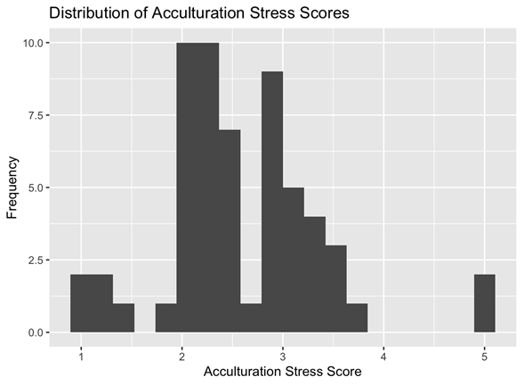
Figure 2
Employment Status and Acculturative stress t-test
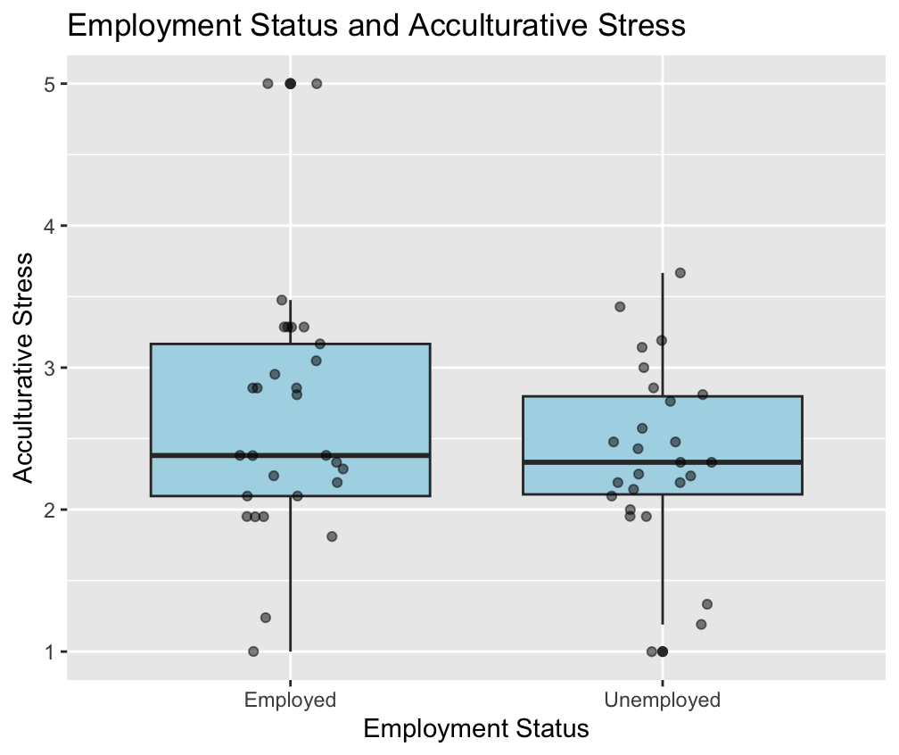

Figure 3
Immigrant generation status and acculturative stress t-test
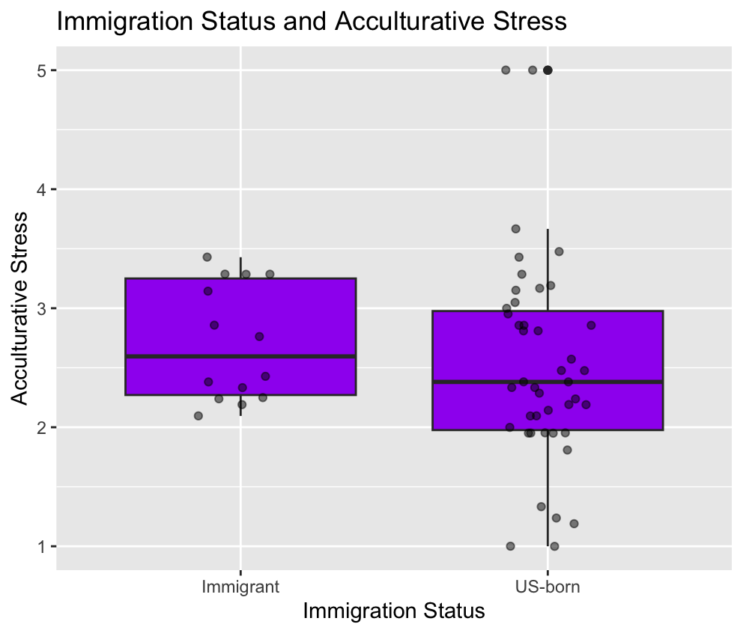
Figure 4
Religiosity and Acculturative stress correlation
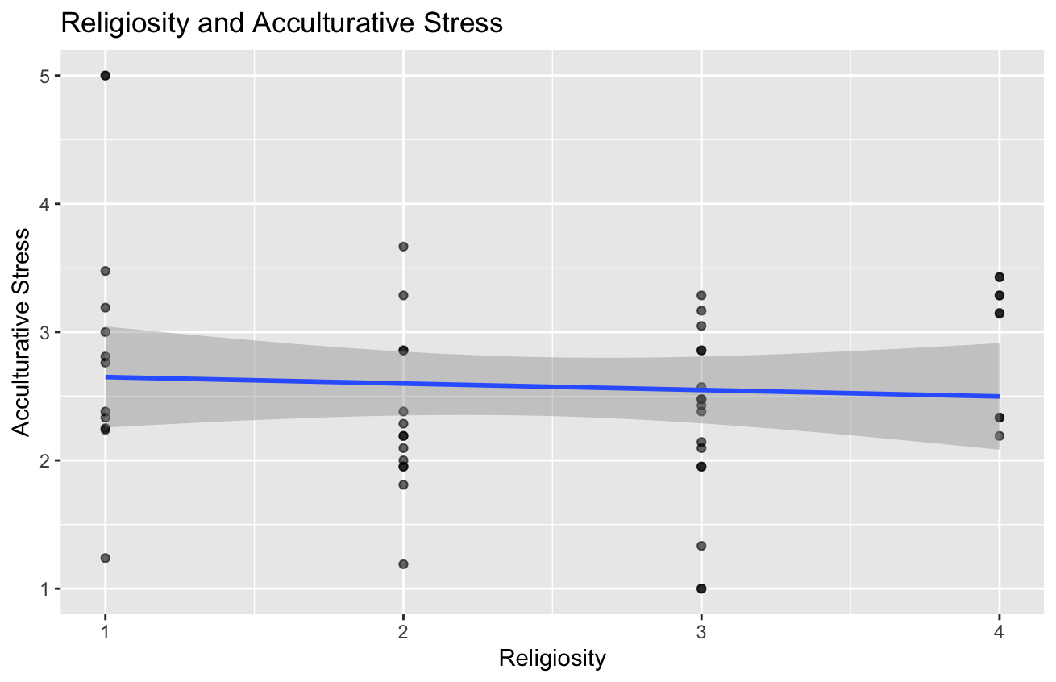
Figure 5
Critical reflection and acculturative stress correlation
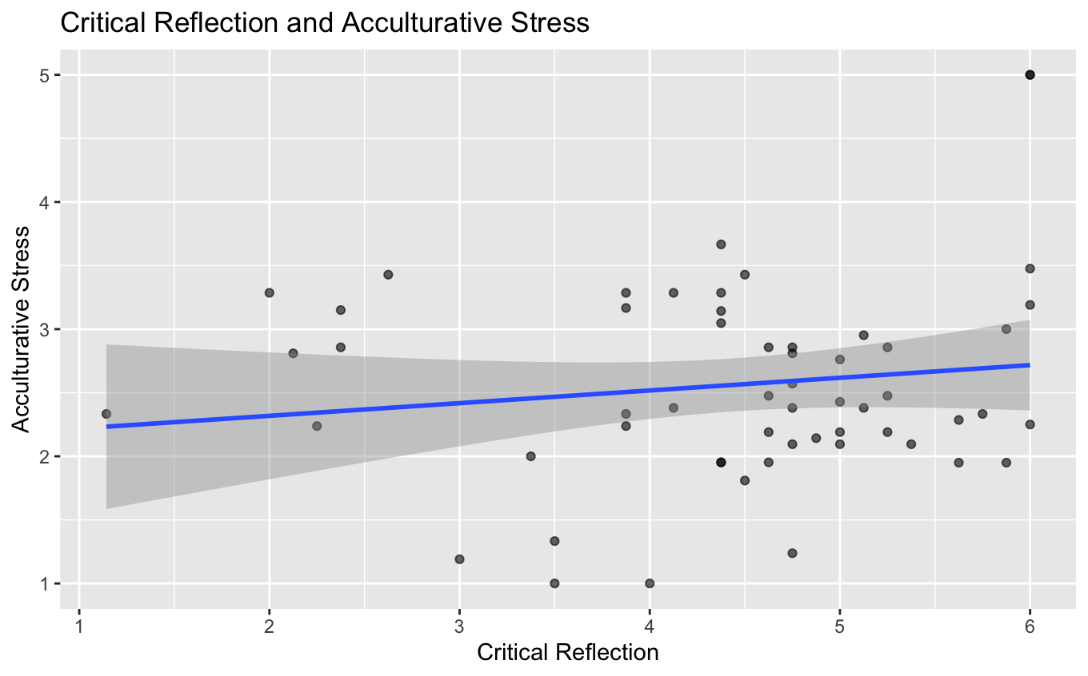

Figure 6
Critical efficacy and acculturative stress correlation
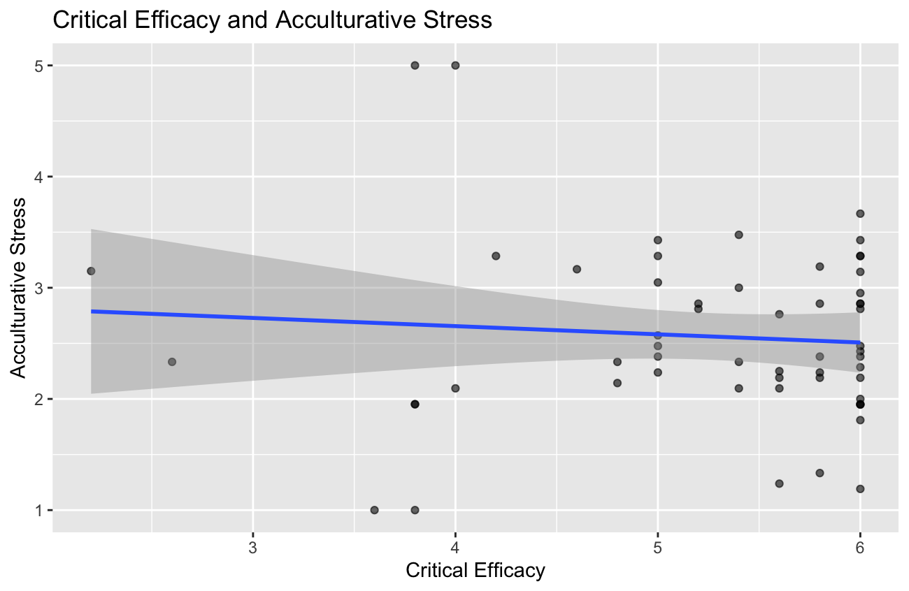

Figure 7
Critical action and acculturative stress correlation
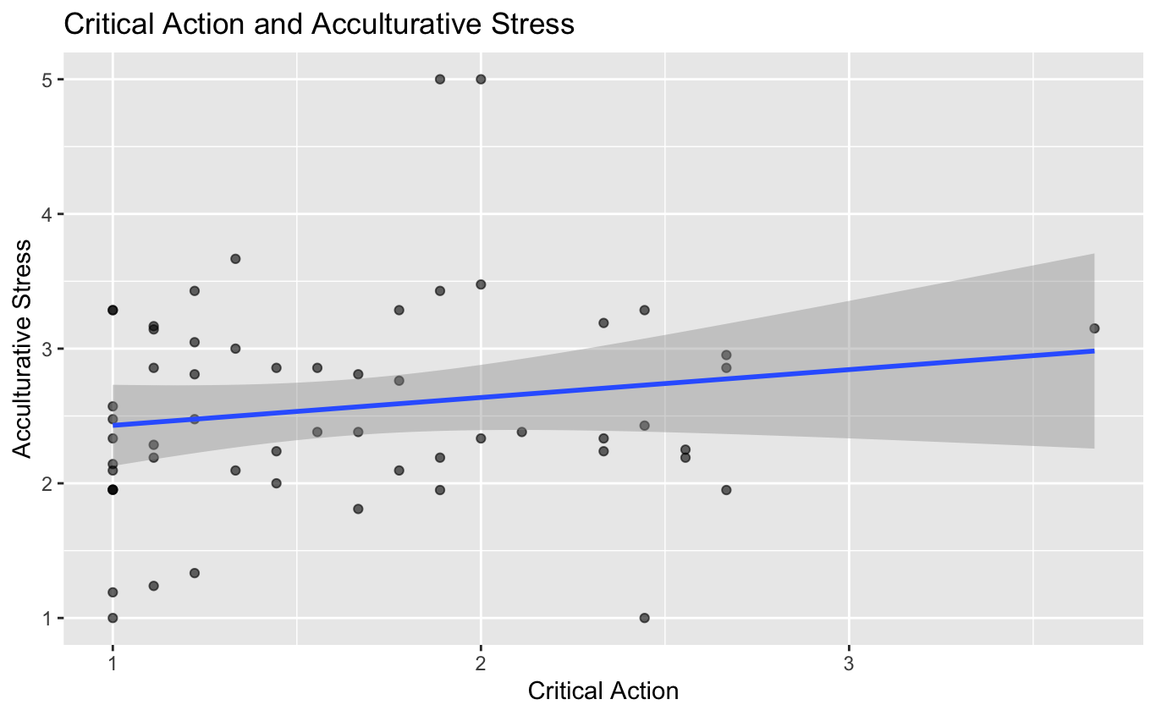

Figure 8
Combined correlations

